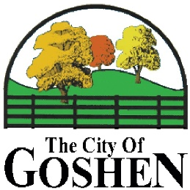
Commission Meeting Agenda
March 15, 2021
Welcome
Minutes – February 22, 2021
Committee Updates from Committee Chair
- Budget and Financials – Bill Rolfes
- Parks – Bill Rolfes
- Beautification – Bill Rolfes
- Stormwater Mitigation – Todd Hall
- Drainage – Todd Hall
- Website – Todd Hall
- Architectural Control – Doug Morales
- Street & Public Works – Doug Morales
- Ordinance Enforcement – Jeff Mangan
- Public Protection – Jeff Mangan
- Snow Removal – Bobby Thacker
- Sanitation – Bobby Thacker
- Newsletter – Bobby Thacker
- Administrative – Bobby Thacker
  - Budget Meeting: Monday, April 26, 2019 at 7:00 pm
Old Business
New Business
Public Comment
Adjourn

